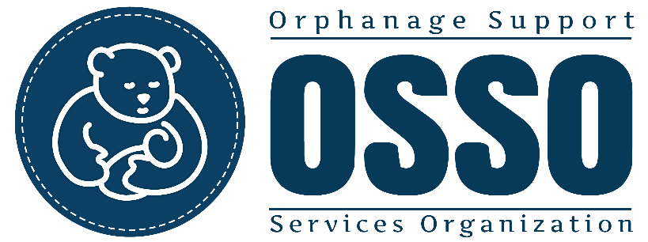
Thank you for participating in fundraising for the children OSSO serves! Please submit this form and any inquiries to info@orphanagesupport.org. Your fundraising website will be created, and a link will be sent to use to share via social media. All funds donated will be deposited directly into OSSO’s bank account to be used for your funded purpose.
Volunteers may choose to fundraise to cover the program fees they are invoiced. Any funds raised in excess of the amount invoiced to a volunteer will be used as a direct donation for the orphanage.
OSSO is a 501(c)3 non-profit organization. Tax receipts will be mailed to those who donate through the fundraising website created by OSSO. Tax receipts are sent in January of the following year by the federal deadline.
OSSO cannot use any of the funds raised to purchase airfare or other personal expenses for a volunteer. No funds will be withdrawn to be given to the volunteer. If a donor wishes to pay for airfare or personal expenses of a volunteer, the money must be given directly to that volunteer.

Group or Individual Fundraiser?
Names of everyone participating
Goal Amount
Deadline Date
Title of Fundraiser

Please attach any photos or videos you would like added to your fundraiser. Photos all need to be in the .jpg format and attached to the e-mail with this form.
Description- Tell your story. Cover WHAT, WHO, and WHY. If writing as a group, consider including an introduction paragraph followed with short personal comments from group members. Names and identifying information of the children may not be shared. However, we encourage you to add a personal touch with your own stories and experiences.

